SMART BLIND STICK USING ULTRA SONAR SENSORS WITH VOICE ASSIST
Ramkumar K S ksramkumar276@gmail.com
Samandeep kour kaursamandeepk@gmail.com
Mamidi sai venkata vignesh mamidisaivenkatavignesh@gmail.com Mohand Sai Reddy mohandsaireddy2004@gmail.com Hemnath A hemnathaki@gmail.com

ABSTRACT:
The smart walking stick helps blind people to perform navigation and to do their work easily and comfortably. In normal stick, the detection of the obstacle is not done and normal stick is not efficient for visually impaired persons. Because the blind person does not know what type of things or what type of the objects come in front of him or her. The person cannot recognize what is the size of that object and how far is he/she from the object. It is difficult for blind person to move here and there. In smart walking stick, the object is detected with the help of a ultra sonic sensor which detects the distance between object and the person. If any obstacle comes in front of blind person, he/she can know about the obstacle by hearing the sound generated by the BUZZER. The system is very useful for people who are visually impaired and are often need help from others.

INTRODUTION:
Visually Impaired persons have difficulty to interact and feel their environment. They have little contact with surroundings. Physical movement is a challenge for visually impaired persons, because it can become tricky to distinguish obstacles appearing in front of them, and they are not able to move from one place to another. They depend on their familiefor mobility and financial support. Their mobility opposes them from interacting with people and social activities. In the past, different systems are designed with limitations without a solid understanding of the no visual perception. Researchers have spent the decades to develop an intelligent and smart stick to assist and alert visually impaired persons from obstacles and give information about their location. Over the last decades, research has been conducted for new devices to design a good and reliable system for visually impaired persons to detect obstacles and warn them at danger places. Smart walking stick is specially designed to detect obstacles which may help the blind to navigate care-free. The audio messages will keep the user alert and considerably reduce accidents. A voice enabled automatic switching is also incorporated to help them in private space as well. This system presents a concept to provide a smart electronic aid for blind people, both in public and private space The proposed system contains the ultrasonic sensor, water sensor, voice play back board, raspberry pi and speaker. The
proposed system detects the obstacle images which are present

in outdoor and indoor with the help of a camera. The Stick
measures the distance between the objects and smart walking stick by using an ultrasonic sensor. When any International

objects or obstacles come in range of an ultrasonic sensor then the buzzer tell the name of obstacle which is in front of the stick. The smart walking stick is a simple and purely mechanical device to detect the obstacles on the ground. This device is light in weight

and portable. But its range is limited due to its own size. It provides the best travel aid for the person. The blind person can move from one place to another independently without the others help. The main aim of the system is to provide a efficient navigation aid for the blind persons which gives a sense of vision by providing the information about their surroundings and objects around them. In case the stick is lost around him a rf transmitter is induced in the stick along with arduino and ultra sonic sensor and the blind person
MODEL:
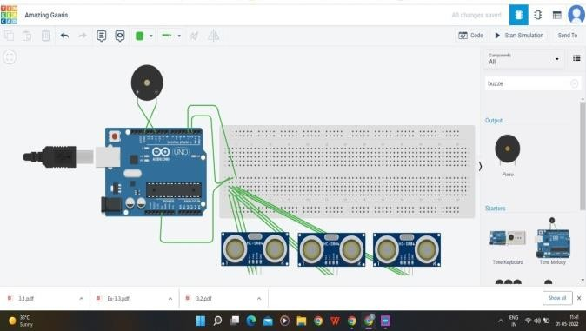
Fig a
The above tinker cad circuit diagram (fig a) is taken as the reference for making the model

LITERATURE SURVEY:
This project was developed by (M.H. Mahmud, R. Saha and S. Islam). The author proposes a function of a microcontroller that have code protected so its security bridge cannot be override except the vendor or owner. It produces different Pulse Width Modulation (PWM) based on the sensors output to operate pager motor. The author focused on the easy way to use the stick and it’s maintain, cheap and it is very comfortable to use for blind people. The author approach with subsystems fundamentally sensor based with integral scheme is designed with a circuitry fundament on a PIC microcontroller. The power consumption is low and can be operated easily. The stick is very economic over the conventional one. The Smart Stick acts as a basic platform for the coming generation of more aiding devices to help the visually impaired to navigate safely both indoor and outdoor. It is effective and affordable. It leads to good results in detecting the obstacles on the path of the user in a range of three meters. This system offers a low-cost, reliable, portable, low power consumption and robust solution for navigation with obvious short response time.[1] M.H. Mahmud, R. Saha and S. Islam (February 2015)
[GIVEN IN “Smart Ultrasonic Walking Stick for Visually Impaired People,
-Manisha Gend”]

Problem statement:
As we are seeing in places atleast 3% of people are having some defects, in that blindness is also a problem. In daily life a blind person has to face a lot of challenges. They cannot walk alone in crowded places,places where stairs are used to go on higher floors, crossing roads,and many other problems. An ordinary blind stick also known as white cane which is used by most of the blind peoples is not very beneficial for them as it doesn’t warn that there is a hurdle in front of them or there is any danger infront of them. If they get a stick with voice intimation that can warn them about the dangers coming infront of them then it would be the best thing by which their we can help them to move independently. It can be the most convenient way for them if they know the problem coming infront of them earlier.

IMPLEMENTATION:
- Hardware Requirement

  - Aurdino Nano
  - Buzzer
  - Ultrasonic sensor
  - Breadboard
  - Jumper cables
  - Power supply 2)Software Requirements
    - Aurdino Compiler

SYSTEM CONFIGURATION :
The smart stick, as shown in Fig. b, is basically an embedded system integrating the following pair of ultrasonic sensor to detect obstacles in front of the blind from ground level height to head level height of the stick in the range of 5inches(customizable) ahead, infrared sensor to detect upward and downward stairs,. The sensors collect the real-time data and send it to the microcontroller for processing. After processing, the. microcontroller invokes the right speech warning message through a speaker. The system is powered by a rechargeable battery.

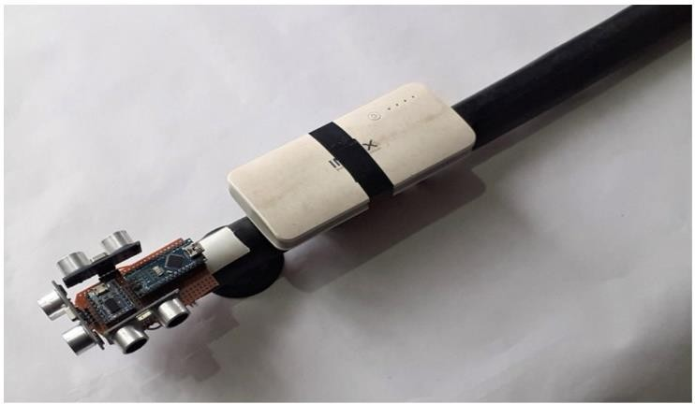

FIG(b)
The total set up is of made for 180 degrees around the working model so it can detect the obstacles in up and down and in left and right positions . it detects the object only in front as in back user will also be detected and it will fall in error .

METHODOLOGIES:
As it has been noted earlier the implanted smart walking stick scheme corresponds of several subsystems. These subsystems fundamentally sensor based.
The sensor based circuitry consisting of sensors Ping Sonar Sensor is used to detect ranges from obstacles, GH311 Ultrasonic Obstacle Sensor is applied to notice what's at the bottom of the stick i.e. the terrain [4], a pair of electrodes are used to observe wetness at its underneath. A PIC16F690 microcontroller reads these sensors.. An audio output is designated by a buzzer alarm. The output signals are operated by PWM to hold distinct sound form as well as it indicates the scheme’s status. The output indications provided by the microcontroller are distinctive as per sensor. Based on the strength of vibration of the motor or the beeping of the buzzer embedded with the stick a disabled person may determine if he/she is walking towards a manhole or an edge or a large opening at nearby bottom or something similar. At the same time he/she may get the sense of his/her distance from nearby objects and if he/she is walking in a wet or muddy or potentially slippery terrain. The microcontroller and power circuitry (preferably battery based) are the crucial part of the scheme. The simplicity of the design makes it easy to use by any person and at the same time the cost of manufacturing such sticks is kept low.

GENERAL DESCRIPTION OF EQUIPMENTS:
Aurdino Nano:

Power
The Arduino Nano can be powered via the Mini-B USB connection, 6-20V unregulated external power supply (pin 30), or 5V regulated external power supply (pin 27). The power source is automatically selected to the highest voltage source.the ATmega328 has 32 KB, (also with 2 KB used for the bootloader. The ATmega328 has 2 KB

Input and Output

Each of the 14 digital pins on the Nano can be used as an input or output, using pinMode(), digitalWrite(), and digitalRead() functions. They operate at 5 volts. Each pin can provide or receive a maximum of 40 mA and has an internal pull-up resistor (disconnected by default) of 20-50 kOhms. In addition, some pins have specialized functions:

- Serial: 0 (RX) and 1 (TX). Used to receive (RX) and transmit (TX) TTL serial data. These pins are connected to the corresponding pins of the FTDI USB-to-TTL Serial chip.
- External Interrupts: 2 and 3. These pins can be configured to trigger an interrupt on a low value, a rising or falling edge, or a change in value. See the attachInterrupt() function for details.
- PWM: 3, 5, 6, 9, 10, and 11. Provide 8-bit PWM output with the analogWrite() function.
- SPI: 10 (SS), 11 (MOSI), 12 (MISO), 13 (SCK). These pins support SPI communication, which, although provided by the underlying hardware, is not currently included in the Arduino language.
- LED: 13. There is a built-in LED connected to digital pin 13. When the pin is HIGH value, the LED is on, when the pin is LOW, it's off.

The Nano has 8 analog inputs, each of which provide 10 bits of resolution (i.e. 1024 different values). By default they measure from ground to 5 volts, though is it possible to change the upper end of their range using the analogReference() function. Analog pins 6 and 7 cannot be used as digital pins. Additionally, some pins have specialized functionality:

- I2C: A4 (SDA) and A5 (SCL). Support I2C (TWI) communication using the Wire library (documentation on the Wiring website).

There are a couple of other pins on the board:
from the Tools > Board menu (according to the microcontroller on your board).
The ATmega328 on the Arduino Nano comes preburned with a bootloader that allows you to upload new code to it without the use of an external hardware programmer. It communicates using the original STK500 protocol.
You can also bypass the bootloader and program the microcontroller through the ICSP (In-Circuit Serial Programming) header using Arduino ISP or similar.
And it has automatic software reset

BUZZER:
The buzzer is a sounding device that can convert audio signals into sound signals. It is usually powered by DC voltage. It is widely used in alarms, computers, printers and other electronic products as sound devices. It is mainly divided into piezoelectric buzzer and electromagnetic buzzer, represented by the letter "H" or "HA" in the circuit. According to different designs and uses, the buzzer can emit various sounds such as music, siren, buzzer, alarm, and electric bell.

ULTRA SONIC SENSOR:

An ultrasonic sensor is an instrument that measures the distance to an object using ultrasonic sound waves.
An ultrasonic sensor uses a transducer to send and receive ultrasonic pulses that relay back information about an object’s proximity.
High-frequency sound waves reflect from boundaries to produce distinct echo patterns.

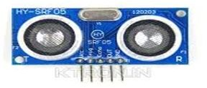
- AREF. Reference voltage for the analog inputs. Used with analogReference().
- Reset. Bring this line LOW to reset the microcontroller. Typically used to add a reset button to shields which block the one on the board.

PROGRAMING:

WORKING:

Fig c

The Arduino Nano can be programmed with the Arduino software.Select "Arduino Duemilanove or Nano w/ ATmega328"
Ultrasonic sensors work by sending out a sound wave at a frequency above the range of human hearing. The transducer of

the sensor acts as a microphone to receive and send the ultrasonic sound. Our ultrasonic sensors, like many others, use a single transducer to send a pulse and to receive the echo. The sensor determines the distance to a target by measuring time lapses between the sending and receiving of the ultrasonic pulse.
The working principle of this module is simple. It sends an ultrasonic pulse out at 40kHz which travels through the air and if there is an obstacle or object, it will bounce back to the sensor. By calculating the travel time and the speed of sound, the distance can be calculated.
Ultrasonic sensors are a great solution for the detection of clear objects. For liquid level measurement, applications that use infrared sensors, for instance, struggle with this particular use case because of target translucence.
For presence detection, ultrasonic sensors detect objects regardless of the color, surface, or material (unless the material is very soft like wool, as it would absorb sound.)
To detect transparent and other items where optical technologies may fail, ultrasonic sensors are a reliable choice.

BREADBOARD:

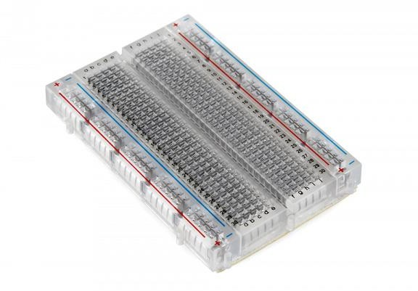
Breadboards are one of the most fundamental pieces when learning how to build circuits. In this tutorial, you will learn a little bit about what breadboards are, why they are called breadboards, and how to use one. Once you are done you should have a basic understanding of how breadboards work and be able to build a basic circuit on a breadboard (fig d) .
An electronics breadboard (as opposed to the type on which sandwiches are made) is actually referring to a solderless breadboard. These are great units for making temporary circuits and prototyping, and they require absolutely no soldering.
Prototyping is the process of testing out an idea by creating a preliminary model from which other forms are developed or copied, and it is one of the most common uses for breadboards. If you aren’t sure how a circuit will react under a given set of parameters, it’s best to build a prototype and test it out.

JUMOER CABLES:
A jumper wire is a short insulated wire with bare (stripped of insulation) ends. You use jumper wires, such as the one shown in the following figure, to connect two points in a breadboard circuit. Even if you have a set of precut jumper wires, chances are you'll need to make a jumper wire of a specific length for a circuit or two.
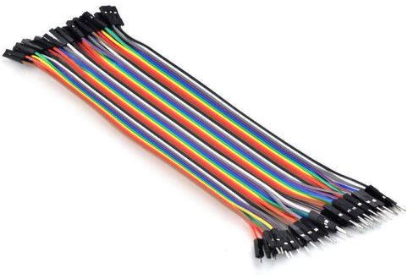

Fig f

POWER SUPPLY:
  - 20000mAH
    - USB rechargeable
    - Can be used as a power source for Arduino nano

Power banks work by using sophisticated electronics to manage taking in charge from a charger, storing it in a battery and then charging other devices. Power banks are not just a simple battery: they use sophisticated electronics circuitry to manage being charged, and then charging other devices.

ARDUINO IDE:
The Arduino Integrated Development Environment - or Arduino Software (IDE) - contains a text editor for writing code, a message area, a text console, a toolbar with buttons for common functions and a series of menus. It connects to the Arduino hardware to upload programs and communicate with them.

IMPLEMENTATION:
CONNECTIONS:
- The trig pin of the each sonar sensors is connected to the input voltage pin of ‘5V’ of the Arduino nano

- The VCC and ECHO oin of the sonar sensors is connected to the ‘D1’ and ‘D2’ of the Arduino nano for input .
- The GND and the D11 is connected to the speaker for the output .
- Then the code is uploaded to the Arduino nano then the working model starts working

Working:
Connections are made as per the above description
The 5V will give the power supply to the ultra sonar sensors the VCC and ECHO will be the input and output of the sensors as per the program description if the object detected it will give signal to Arduino board and the buzzer will beep to alert the user

CODE:
//Ultasonic Sensor

//Pins connected to the ultrasonic sensor #define trigPin 2
#define echoPin 3

//LED pins
#define ledGreen 9

#define ledRed 8
//Pin connected to the piezo buzzer #define alarm 11

int range = 5;//range in inches

void setup() {

// initialize serial communication: Serial.begin(9600);
//initialize the sensor pins pinMode(trigPin, OUTPUT); pinMode(echoPin, INPUT);

//initialize LED pins pinMode(ledGreen, OUTPUT); pinMode(ledRed, OUTPUT);
//set LEDs digitalWrite(ledGreen, HIGH); digitalWrite(ledRed, LOW);
}

void loop()
{

// establish variables for duration of the ping,
// and the distance result in inches and centimeters: long duration, inches, cm;

// The PING))) is triggered by a HIGH pulse of 2 or more microseconds.
// Give a short LOW pulse beforehand to ensure a clean HIGH pulse:

digitalWrite(trigPin, LOW); delayMicroseconds(2); digitalWrite(trigPin, HIGH); delayMicroseconds(5); digitalWrite(trigPin, LOW);

// Take reading on echo pin duration = pulseIn(echoPin, HIGH);

// convert the time into a distance
inches = microsecondsToInches(duration); cm = microsecondsToCentimeters(duration);

Serial.print(inches); Serial.print("in, "); Serial.print(cm); Serial.print("cm"); Serial.println();

if(inches < 12) { Serial.println("DANGER"); digitalWrite(ledGreen, LOW); digitalWrite(ledRed, HIGH); tone(alarm, 2000);

delay(100);
} else { Serial.println("GOOD");

digitalWrite(ledGreen, HIGH); digitalWrite(ledRed, LOW); noTone(alarm);
delay(100);

}

delay(200);

}

long microsecondsToInches(long microseconds)

{
// According to Parallax's datasheet for the PING))), there are

// 73.746 microseconds per inch (i.e. sound travels at 1130 feet per
// second). This gives the distance travelled by the ping, outbound

// and return, so we divide by 2 to get the distance of the obstacle. return microseconds / 74 / 2;
}

long microsecondsToCentimeters(long microseconds)
{

// The speed of sound is 340 m/s or 29 microseconds per centimeter.
// The ping travels out and back, so to find the distance of the

// object we take half of the distance travelled. return microseconds / 29 / 2;
}

ADVANTAGES:
- The system enables the blind people to move with the same ease and confidence as sighted people.

- Avoid the obstacle based on ultrasonic sensor.

- Facilates the easier communication in case of emergency.

- Auto detection.

- Simple to use.

CONCLUSION:
The Blind Walking Stick has been finally made into prototype which can be used to guide the blind . Its aims to solve the problems
faced by the blind people in their daily life. The system also takes the measure to ensure their safety . Smart blind Stick will operate to help all the blind people in the world to make them easier to walk everywhere they want. It was done to help the blind to move infront very well. It is used to help the people with disabilities that are blind to facilitate the movement and increase safety.
The paper intended the blueprint and architecture of a smarter concept of SMART WALKING STICK for blind and disable people. This blind aid system can be rendered a fresh dimension of useful assistance and gives a sense of artificial vision along with dedicated obstacle and hollow detection circuitry. This cost effective and light weight device can be designed to take of pattern of a clastic and portable device, which can be unconditionally mounted on an ordinary white cane or blind stick. The aimed combination of several working sub-systems makes a time demanding system that monitors the environmental scenario of static and dynamic objects and provides necessary feedback forming navigation more precise, safe and secure.

REFERENCES :
  - Johann B., Iwan U., ―The Guide Cane — A Computerized Travel Aid for the Active Guidance of Blind Pedestrians‖ proceedings of the IEEE International Conference on Roboticsand Automation, Albuquerque, NM, 1283-1288, 1997.

  - Koley, S. & Mishra, R., 2012. VOICE OPERATED OUTDOOR NAVIGATION SYSTEM FOR VISUALLY IMPAIRED PERSONS. International Journal of Engineering Trends and Technology.
  - Osama Bader AL-Barrm International Journal of Latest Trends in Engineering and Technology(IJLTETJ)
  - Smart Cane Assisted Mobility for the Visually Impaired, World Academy of Science, Engineering and technology International Journal and Information Engineering Vol:6 No:10,2012
  - G. Prasanthi and P. Tejaswidho Sensor assisted Stick for the Blind People-Transmission on Engineering and Sciences, vol:3,number 1, pp-, 12-16,2015.
  - Ulrich, J. Borenstein, The GuideCane –Applying Mobile Robot Technologies to Assist the visually impaired, IEEE Tr.SMC, Vol:31, No.2, March 2001.
  - Designing an ultrasonic stick prototype for blind people -SULARSO BUDILAKSONA( UNIVERSITY OF PERSADA , INDONESIA
  - Smart Ultrasonic Walking Stick for Visually Impaired People -Manisha Gend(Zeal College of Engineering and Research, Pune)

  - Review on smart blind stick -Aravind Lal
  - Smart blind stick design and implementation - Amira.A.Elsonbaty
  - Walking aid stick for visually challenged people - Vinutha H
  - Smart Blind Stick Using Ultrasonic Sensor -T. Tirupal
  - Smart Blind Stick For Obstacle Detection and Navigation System -Amit Kumar Thakur

  - Voice controlled blind stick to guide for blind people - Abhijit Pathak
  - Smart blind stick by Ardiuno -R.Dhanujha
  - Smart Walking Stick for Visually Impaired People Using Ultrasonic Sensors and Arduino - Dada Emmanuel Gbenga

  - Smart Blind Stick Connected System Using Arduino - G.Srinivas
  - Smart walking stick - an electronic approach to assist visually disabled persons -Mohammad Hazzaz Mahmud
  - Ultrasonic sensor based smart blind stick -Naiwrita Dey

